School of Electronics and Communication Engineering
Second Year B. Tech. (ECE-AI-ML)

Microcontroller and Applications
Course Code: ECE2PM04A

Laboratory Manual
2024-2025
Semester - IV

Preface
Microcontroller and Applications

Microcontrollers are small computers that consist of a single System-on-Chip (SoC) that includes a CPU, memory, and additional peripheral components. By using a single chip, the computing element's footprint within the entire system package is reduced, obviating the need for additional chips. Microcontrollers in this category include PIC , 8051 and many more . The 8-bit Microcontroller C8051F340 from Silicon Labs, which employs the conventional 8051 architecture with enhanced functionality needed to design embedded products, is included in this course. Undergraduate students are introduced to the field of microcontrollers, including their definition, operation, and interface with I/O devices such as keyboards, motors, and displays. Additionally, hardware-based programming in assembly and embedded C is covered in the microcontroller course. There will also be an explanation of several system design examples centered around these CPUs. This course's lab consists of studies involving the C8051F340 peripheral interface. Assembly and embedded C programming are done using Keil µvision and Simplicity Studio as the IDE. Knowledge of Microcontroller enhances employability in companies specializing in hardware development and semiconductor manufacturing. Microcontroller programming skills are highly sought after by companies involved in the development of embedded products.

Microcontroller and Applications
I N D E X
Sr. No. | Name of the Experiment | Page | Date of Checking | Signature of Batch I/C
1 | Simple assembly language programming.
2 | Complex assembly language programming
3 | Interfacing of LED, Buzzer, Relay and Switch with C8051F340
4 | Interfacing of LCD with C8051F340
5 | Interfacing DAC with C8051F340.
6 | Interfacing ADC with C8051F340.
7 | Interfacing the DC motor and control its speed using PWM with C8051F340.
8 | Implement UART with C8051F340
9 | Interfacing Stepper Motor with C8051F340.
10 | Interfacing EEPROM using SPI with C8051F340.

CERTIFICATE
Certified that Mr./Ms.__________________________________________ of Class S. Y. B. Tech. (ECE) Division_____ Roll No.____________ has completed the laboratory work in the subject Microcontroller and Applications during Semester IV in the School of Electronics and Communication Engineering during the Academic Year 2023-2024.

Signature of the Faculty Program Director
Department of EEE
Laboratory Instructions
Microcontroller and Applications

- Students should have a valid ID card before entering the laboratory.
- Playing games on a computer in the lab is strictly prohibited.
- Before leaving the lab, users must close all programs/windows and turn-off the computer.
- Do not modify or delete any important file and install any software or settings in the computer
- Internet facility is to be used only for educational/ study purposes.
- If any problem arises, please bring the same to the notice of Lab In-Charge.
- Each student must take mobile phones in “Switched Off” or “Vibration” mode while entering and or working in the laboratory.
- In case of theft / destruction of the computers or peripherals, double the cost of that item will be charged from the student/user.
- Tampering with the hardware or software settings will not be tolerated.
- Lab Assistants are available to assist with basic computer and software problems.
- Copying and/or installing pirated software is not permitted.
- Personal files are not to be stored on the local drive. Students are responsible for their own means of digital storage. All lab computers are configured to remove any data stored or any programs installed by users.
- Do not leave your personal belongings at the computer desk. The School is not responsible for items left behind.
- Users are strictly prohibited from downloading, viewing or distributing any offensive materials.
- Internet surfing or chatting for personal reasons is not allowed.

Guidelines to use µVISION IDE
Keil MicroVision is an Integrated Development Environment (IDE), which includes a text editor to write programs, a compiler to convert the source code to hex files and a debugger to test, verify, and optimize the application code.
Keil µVision can be used for:
- Writing programs in C/C++ or Assembly language
- Compiling and Assembling Programs
- Debugging program
- Creating Hex and Axf file
- Testing the program without real Hardware (Simulator Mode)
Step 1: After opening Keil uVision, Go to Project tab and
Create new µVision project
Now Select the new folder and give the name to Project.
Step 2: After Creating project now Select your device model eg. Silicon Lab’s C8051F340
Step 3: So now your project is created and the Message window will appear to add the start-up file of your device. Click on Yes so it will be added to your project folder you are programming in C and click on No if you are programming in assembly.
Step 4: Now go to File and create new file and save it with .asm extension in the folder where you created the project if you want to write program in assembly language
Step 5: Now write your program and save it again.
Step 6: After that on the left you see the project window [if it’s not there….go to View tab and click on restore window to default].
Now come on Project window.
Right click on target and click on options for target
Here you can change your device also.
Step 7: Now Expand target and you will see source group
Right click on group and click on Add existing files to source group
Now add your program file which you have written in C/assembly.
You can see the program file added under the source group.
Step 8: Now Click on translate and then Build target. You can find it under Project tab or in the toolbar. It can also be done by pressing the F7 key.
Step 9: you can see Status of your program in Build output window
[If it’s not there go to view and click on Build output window]
Now you are done with your program.
Open the debugger and verify your program.
Keil is a tool which can be used as a debugger and simulator.
NOTE: Use this tool for Experiment No. 1 and 2.

S. Y. B. Tech (ECE)
Semester: IV Subject: Microcontroller and Applications
Name: Class:
Roll No: Batch:
Experiment No: 01 and 02
Name of the Experiment:
1. Simple Assembly language programming.
2. Complex Assembly language programming.

Marks
Teacher’s Signature with date
Performed on:
Submitted on:

Aim:
1. Simple Assembly language programming.
a. Write assembly language program for addition of two 8-bit numbers.
b. Write assembly language program for addition of two 16-bit numbers.
b. Write assembly language program for addition of N 8-bit numbers Take the input numbers from memory and store the result in memory.
2. Complex Assembly language programming.
a. Find the square of a number using DPTR.
b. Program to count number of 1’s in a given byte.
c. Program to count number of Odd and Even numbers from a given array.
d. Program to find positive and negative numbers
Theory:
Programming in the sense of Microcontrollers (or any computer) means writing a sequence of instructions that are executed by the processor in a particular order to perform a predefined task. The three levels of Programming Languages are as shown in figure 1.1.

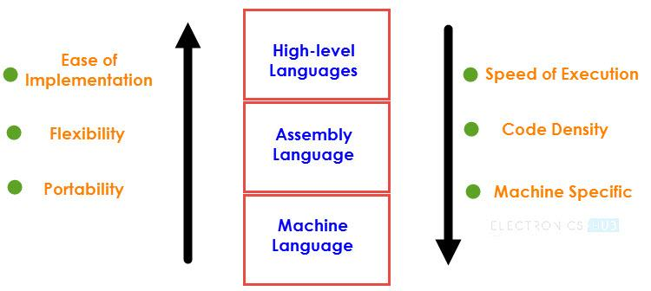
Figure1.1: Programming Languages
Assembly Language is a pseudo-English representation of the Machine Language. The 8051 Microcontroller Assembly Language is a combination of English like words called Mnemonics and Hexadecimal codes with the following advantages:
- The Programs written in Assembly gets executed faster and they occupy less memory.
- With the help of Assembly Language, you can directly exploit all the features of a Microcontroller.
- Using Assembly Language, you can have direct and accurate control of all the Microcontroller’s resources like I/O Ports, RAM, SFRs, etc.
- Compared to High-level Languages, Assembly Language has less rules and restrictions.

Syntax of CIP51 Instruction:
[ Label:] Instructions [;Comments]
CIP51 has about 109 instructions. These can be grouped into the following categories
- Arithmetic Instructions
- Logical Instructions
- Data Transfer instructions
- Boolean Variable Instructions
- Program Branching Instructions
The ADD instruction is used for the addition of two operands. The destination operand is always in register A, while the source operand can be register, immediate data or memory. The AF, CY and P bits of the flag register are affected by the ADD instruction depending on the operands. Program Status Word (PSW) is the flag register as shown in figure 1.2.
Bit 7 | Bit 6 | Bit 5 | Bit 4 | Bit 3 | Bit 2 | Bit 1 | Bit 0
CY | AC | FO | RS1 | RS0 | OV | UD | P
Figure1.2: Bit fields in Program Status Word (PSW) Register
Table 1.1: Functions of flags
Symbol | Function
CY | Carry flag
AC | Auxiliary Carry flag (For BCD Operations)
F0 | Flag 0 (Available to the user for General Purpose)
RS1,  RS0 | Register bank select:  RS1 RS0 Working Register Bank and Address  0 0 Bank0  0 1 Bank1  1 0 Bank2  1 1 Bank3
OV | Overflow flag
UD | User definable flag
P | Parity flag; P=1 for odd no. of 1’s; P=0 for Even no. of 1’s
Algorithm:

Sample Example:

Program:
Note: Attach the printout of the code and output

Conclusion:

Study Question:
- Explain the instructions: DJNZ, INC, SUBB, MUL.
- What is an IDE?
Additional links:
- https://nptel.ac.in/courses/108105102
- https://www.electronicshub.org/8051-microcontroller-assembly-language-programming/
Guidelines to use Silicon Lab’s Simplicity Studio
Simplicity Studio simplifies the Embedded development process with one-click access to everything developers need to complete their projects using an integrated development environment (IDE) based on Eclipse 4.5.
Steps to create project and program compilation:
Steps:
- Open Simplicity Studio.
- Click File > Import…, to import the project.
- Click General > Existing Projects into Workspace and click Next.
- First Select Root Directory of your Eclipse Template for EPB_F340. Then select “Copy projects into workspace” check box and Click Finish.
- Every time you import a project make sure to rename it. So Right Click Project > Rename or press F2 while selecting project to rename it.
- To write source files, right click on Sources, go to New > Source File and you will see New Source File Wizard. Enter Source File name (For example main.c) then Click Finish.
- To write header files, right click on Includes, go to New > Header File and you will see New Header File Wizard. Enter Header File name (For example main.h) then Click Finish.
- Write your code and then save your Files.
OR
- Copy necessary .c and .h files to your local Sources and Includes project folders respectively. They will be added to your project in Simplicity Studio IDE.
- Click on Build Project in Project>Build Project to compile and build the project.
- After successful building the project the .hex file will be generated in the project folder in the workspace.
Steps to use hardware:
- Connect 9V DC Power supply to the educational practice board for F340
- Connect USB cable between PL4 connector of EPBF340 board and PC.
- Using the RUN/PROGRAM mode selection switch set the board in the program mode by pressing switch SW2 and press reset.
- Using the download tool (USB Bootloader) download the.HEX file to the target board.
- Wait for the “Successfully loaded image” message in the display.
- Connect flat cable between ASK25 and EPBF340 boards according to each experiment’s requirement.
- Using the RUN/PROGRAM mode selection switch, set the board in the run mode by releasing Switch SW2. Apply reset to execute the program.
- Observe the expected output of the experiment.
NOTE: Use this tool for Experiments No. 3 to 10. Draw the interfacing diagram ona separate sheet and attach the printout of the tested code.
F340 Hardware
The EPB-F340Mini is a stand-alone card--allowing developers to evaluate the C8051F340 USB Flash MCU Family to determine if it meets their application requirements. Furthermore, the module is an excellent platform to develop and run software for the 8051 processor. The EPB-F340Mini is shipped with a C8051F340. The EPB-F340Mini allows full speed verification of 8051 code. In addition, an onboard C2 connector provides interface to emulators, with assembly language and ‘C’ high level language debug.

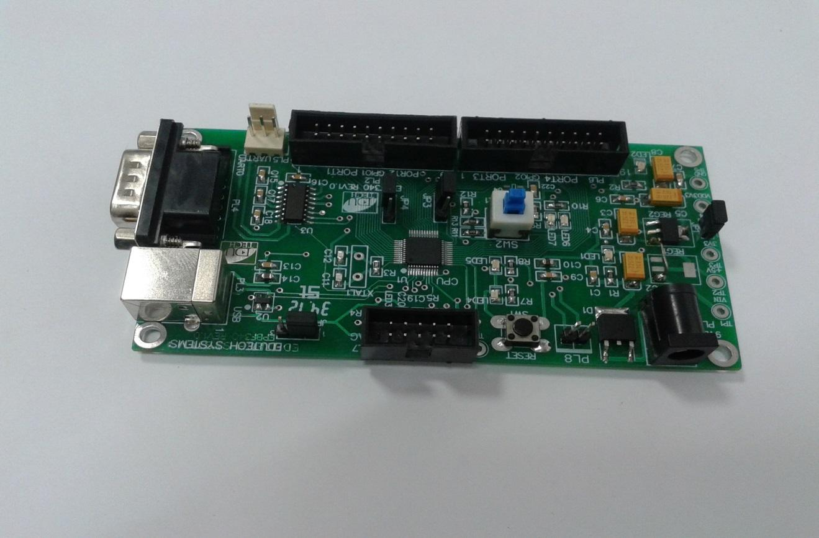
Figure 3.1: The EPB-F340Mini development board
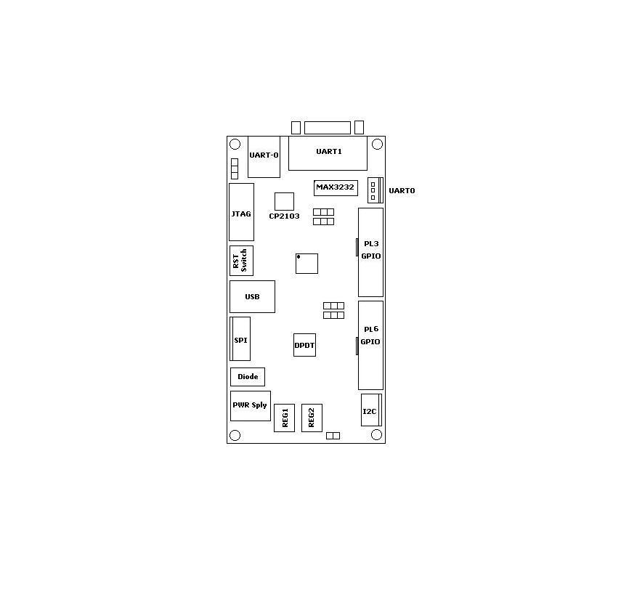
Figure 3.2 The EPB-F340Mini development board layout

The EPB-F340Mini has 8 connectors. The function of each connector is shown in the table below:
Table 3.1 EPB-F340Mini connector description
Unit | Reference | Description
Power jack connector | PL1 | Power jack connector
I2C | PL2 | 4 Pins
I/O Port | PL3 | PORT1 and 2 GPIO
USB | PL4 | USB Connector
JTAG | PL5 | JTAG Interface
I/O Port | PL6 | PORT3 and 4 GPIO
SPI | PL7 | 6 Pins
UART0/Debug | PL8 | USB Connector
UART0 | PL9 | 3 Pins Connector
UART1 | PL10 | DB9 -M Connector

General Purpose I/O Interfacing Kit – ASK 25A
The general purpose I/O interfacing Board is a generic board which focuses on the interfacing of different input and out devices to microcontroller. The board is populated with variety of devices like LED, Key, Relay, LCD, Signal conditioning circuit for ADC, DC motor interface, Stepper Motor interface, I2C EEROM, SPI EEPROM, 2x2 Matrix Key board etc.
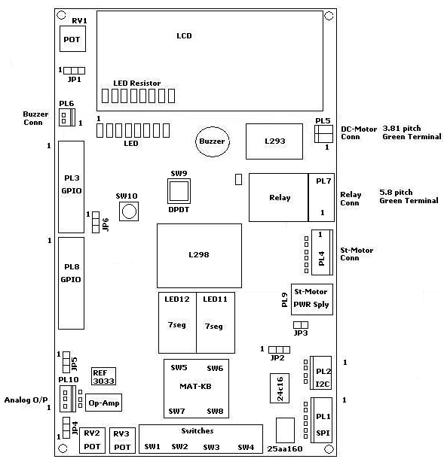
Figure 3.3 The ASK-25 board layout
The ASK-25A has 10 connectors. The function of each connector is shown in the table below:
Table 3.2 ASK-25A connector description
Unit | Reference | Description
SPI | PL1 | 6 Pins
I2C | PL2 | 4 Pins
I/O Port | PL3 | GPIO
Stepper Motor Connector | PL4 | 6 Pins Connector
DC Motor Connector | PL5 | 2 Pin Green Terminal
Buzzer Connector | PL6 | 2 Pin Connector
Relay Connector | PL7 | 3 Pin Green Terminal
I/O Ports | PL8 | GPIO
Stepper Motor Power Supply | PL9 | Power Socket
Analog Output | PL10 | 3 Pin Connector

S. Y. B. Tech (ECE)
Semester: IV Subject: Microcontroller and Applications
Name: Class:
Roll No: Batch:
Experiment No: 03
Name of the Experiment: Interfacing of LED, Buzzer, Relay and Switch with C8051F340

Marks
Teacher’s Signature with date
Performed on:
Submitted on:

Aim: Write C program for interfacing of LED, Buzzer, Relay and Switch with C8051F340 to turn it ON when key is pressed.
Apparatus: EPBF340 Board, ASK25 board, Connectors
Theory:
Ports in C8051F340:
Digital and analog resources are available through 40 I/O pins. These pins are available on ports. C8051F340 has 5 ports, each port has eight pins. Each of the Port pins can be defined as general-purpose I/O (GPIO) or analog input. This resource assignment flexibility is achieved through the use of a Priority Crossbar Decoder. Registers XBR0, XBR1, and XBR2 are used to assign the digital I/O resources to the physical I/O Port pins.
Port I/O Initialization
Port I/O initialization consists of the following steps:
Step 1. Select the input mode (analog or digital) for all Port pins, using the Port Input Mode register (PnMDIN).
Step 2. Select the output mode (open-drain or push-pull) for all Port pins, using the Port Output Mode register (PnMDOUT).
Step 3. Select any pins to be skipped by the I/O Crossbar using the Port Skip registers (PnSKIP).
Step 4. Assign Port pins to desired peripherals (XBR0, XBR1) as shown in figure 2.3.
Step 5. Enable the Crossbar (XBARE = ‘1’).
SFR definitions:
- PnMDIN: Portn Input Mode
0: Corresponding P0.n pin is configured as an analog input.
1: Corresponding P0.n pin is not configured as an analog input.
- PnMDOUT: Portn Output Mode
0: Corresponding P0.n Output is open-drain.
1: Corresponding P0.n Output is push-pull.
- PnSKIP: Portn Skip
0: Corresponding P0.n pin is not skipped by the Crossbar.
1: Corresponding P0.n pin is skipped by the Crossbar.
- XBR0, XBR1, and XBR2 are used to assign the digital I/O resources to the physical I/O Port pins
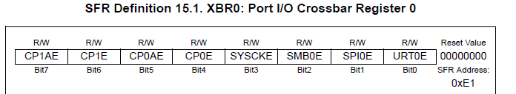

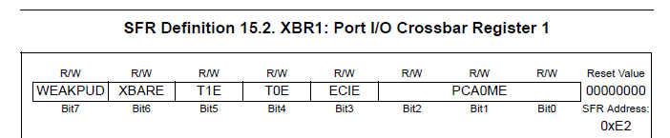

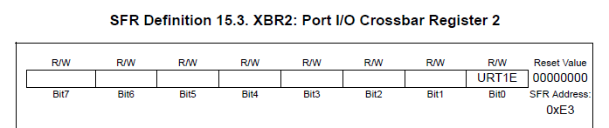

Figure 3.3 Crossbar registers
LED, Buzzer, Relay and Switch:
LED: LED is an output device. 8 LED’s are connected to 8 port pins. The LED’s are connected in common anode configuration. Thus, to turn ON the LED logic ‘0’ must be given and to turn OFF the led logic ‘1’ must be given.
Buzzer: Buzzer is an output device. The buzzer is turned ON when logic ‘1’ is applied to the port pin and turned OFF when logic ‘0’ is applied to port pin.
Relay: Relay is an output device. The relay is turned ON when logic ‘0’ is applied to port pin and turned OFF when logic ‘1’ is applied to the port pin.
Switch/button: Switch is an input device. Push button switches are used. When the switch is released the port pin has logic ‘1’ and when the switch is pushed the port pin has logic ‘0’.
Algorithm:
Interfacing Diagram:
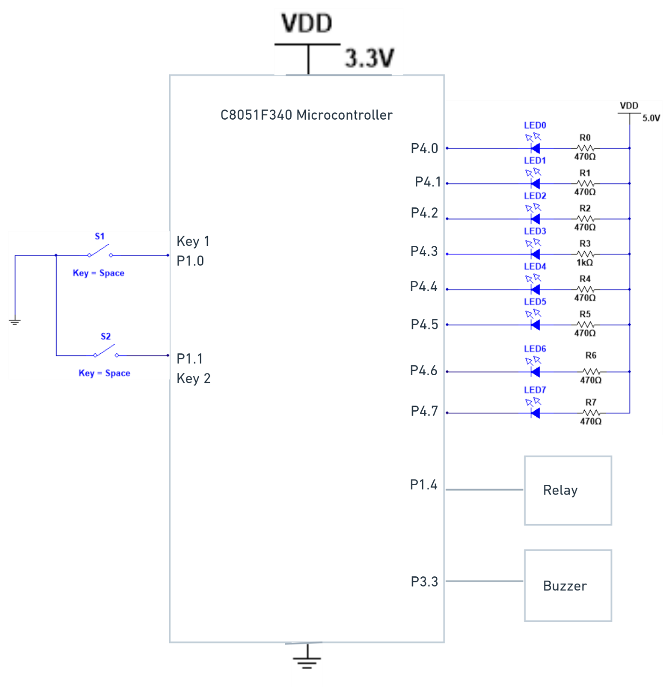
Figure 3.4 LED, Buzzer, Relay, and Switch Interfacing Diagram

Hardware Connections:
Connect flat cable between PL8 connector of ASK25 and PL6 connector of EPBF340 board. Connect other flat cable between PL3 connector of ASK25 and PL3 connector of EPBF340 board.
Table 3.3 Hardware connections between EPBF340 and ASK25 board
Pin Connection | PL8 Connector of ASK25 | PL6 Connector of EPBF340 | PL3 Connector of ASK25 | PL3 Connector of EPBF340
1 |  |  | SW1 | P1.0
2 |  |  | SW2 | P1.1
3 |  |  | SW3 | P1.2
4 | BUZZER | P3.3 | SW4 | P1.3
5 |  |  | RELAY | P1.4
10 | LED1 | P4.0
11 | LED2 | P4.1
12 | LED3 | P4.2
13 | LED4 | P4.3
14 | LED5 | P4.4
15 | LED6 | P4.5
16 | LED7 | P4.6
17 | LED8 | P4.7
18 |  | 3.3 V |  | 3.3 V
19 | 5V | 5.0 V | 5V | 5.0 V
20 | GROUND | GND | GROUND | GND

Program: Attach printout of the tested code.

Expected Result:
LEDs, Buzzer and Relay should turn on when respective key is pressed.

Conclusion:

Study Question:
- Explain the common anode and common cathode configuration of LED.
- How many ports are available in C8051F340?
- How to configure port as an input/output?
- Explain Priority Crossbar Decoder.
Additional links:
- https://www.silabs.com/documents/public/data-sheets/C8051F34x.pdf
- https://aticleworld.com/interfacing-of-switch-and-led-using-the-8051/

S. Y. B. Tech (ECE)
Semester: IV Subject: Microcontroller and Applications
Name: Class:
Roll No: Batch:
Experiment No: 04
Name of the Experiment: Interfacing of LCD

Marks
Teacher’s Signature with date
Performed on:
Submitted on:

Aim: Write C program for interfacing of 16x2 LCD with C8051F340 in 8-bit mode.

Apparatus: EPBF340 Board, ASK25 board, Connectors

Theory:
LCD has the ability to display letters, numbers and characters. A 16x2 LCD can display 16 characters per line and there are 2 such lines. In this LCD each character is displayed in 5x7 pixel matrix.
LCD pin descriptions:
V_{CC} V_{SS} and V_{EE}:
While V_{CC} and V_{SS} provide +5V and ground, respectively, V_{EE} is used for controlling LCD contrast.
Register Select (RS):
There are two very important registers inside the LCD. The RS pin is used for their selection as follows.
- RS = 0: the instruction command code register is selected, allowing the user to send a command such as clear display, cursor at home.
- RS = 1: the data register is selected, allowing the user to send the data to be displayed on the LCD.

Read/write (R/W):
R/W input allows the user to write information to the LCD or read information from it. R/W = 1 when reading, R/W = 0 when writing.
Enable (EN):
The enable pin is used by the LCD to latch information presented to its data pins. When data is supplied to data pins, a high to low pulse must be applied to the pin in order for the LCD to latch in the data present at the data pins. This pulse must be a minimum of 450ns wide.
Data bus (D0 – D7):
The 8-bit data pins, D0-D7 are used to send the information to the LCD or read the contents of the LCD’s internal registers. To display the numbers and letters, we send ASCII codes to these pins while making RS=1.
There are also instruction command codes that can be sent to the LCD to clear the display or blink the cursor.
We also use RS = 0 to check the busy flag bit to see if the LCD is ready to receive information. The busy flag is D& and can be read when R/W = 1 and RS=0. When D7 =1, the LCD is busy taking care of internal operations and will not accept any new information. When D7 = 0, the LCD is ready to receive new information.
Table 4.1 Pin Assignment of 16x2 LCD
Pin number | Symbol | Level | I/O | Function
1 | V_{SS} | - | - | Power supply (GND)
2 | V_{CC} | - | - | Power supply (+5V)
3 | V_{EE} | - | - | Contrast adjust
4 | RS | 0/1 | I | 0 = Instruction input  1 = Data input
5 | R/W | 0/1 | I | 0 = Write to LCD module  1 = Read from LCD module
6 | E | 1, 1->0 | I | Enable signal
7 | DB0 | 0/1 | I/O | Data bus line 0 (LSB)
8 | DB1 | 0/1 | I/O | Data bus line 1
9 | DB2 | 0/1 | I/O | Data bus line 2
10 | DB3 | 0/1 | I/O | Data bus line 3
11 | DB4 | 0/1 | I/O | Data bus line 4
12 | DB5 | 0/1 | I/O | Data bus line 5
13 | DB6 | 0/1 | I/O | Data bus line 6
14 | DB7 | 0/1 | I/O | Data bus line 7 (MSB)
15 | VB+ | 1 | - | Backlight Supply
16 | VB- | 0 | -

In 8-bit mode eight data pins are used. 8-bit ASCII value of a character is sent at a single time period and displayed on the LCD.
Interfacing Diagram:
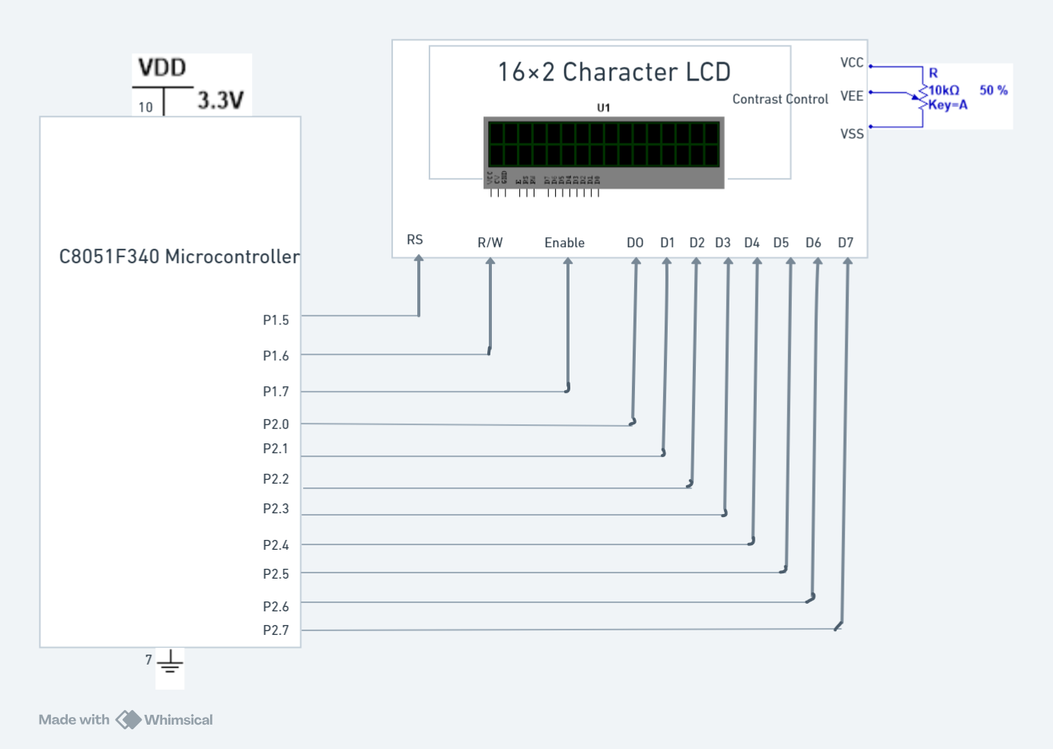
Figure 4.1 Interfacing Diagram of 16x2 LCD with C8051F340

Hardware Connections:
Connect flat cable between PL3 connector of ASK25 and PL3 connector of EPBF340 board.
Table 4.2 Hardware connections between EPBF340 and ASK25 board for LCD Interfacing
Pin Connection | PL3 Connector of ASK25 | PL3 Connector of EPBF340
6 | RS | P1.5
7 | R/W | P1.6
8 | EN | P1.7
9
10 | D0 | P2.0
11 | D1 | P2.1
12 | D2 | P2.2
13 | D3 | P2.3
14 | D4 | P2.4
15 | D5 | P2.5
16 | D6 | P2.6
17 | D7 | P2.7
19 | 5V | 5.0 V
20 | GROUND | GND

Program: Attach printout of the tested code.

Result:
String should be displayed on the LCD.

Conclusion:

Study Question:
- Explain the 4-bit mode of LCD.
- Explain the significance of RS pin and list commands of LCD.

Additional link:
- https://www.electronicshub.org/interfacing-16x2-lcd-8051/
S. Y. B. Tech (ECE)
Semester: IV Subject: Microcontroller and Applications
Name: Class:
Roll No: Batch:
Experiment No: 05
Name of the Experiment: Interfacing of 8-bit DAC with C8051F340

Marks
Teacher’s Signature with date
Performed on:
Submitted on:

Aim: Write C program for interfacing of 8-bit DAC with C8051F340 to generate
- Square wave
- Triangular wave

Apparatus: EPBF340 board, DSO, DSO probes, DAC Board

Theory:
The digital to analog converter involves translating digital information to equivalent analog information. DAC 0808 is R-2R ladder DAC giving output analog current so need to convert in voltage. I to V converter is used using LF351.DAC and LF351 require dual power supply of +15V &-15V.
DAC 0808 features:
- 8 bit digital to analog converter
- Low power consumption 33mW with ± 5V.
- Power supply voltage range ± 4.5V to ± 18V.
- Non-inverting digital inputs are TTL and CMOS compatible.
- 16 pin DIP.
- High speed multiplying input slew rate: 8mA/⎧s.
- Relative accuracy - ± 0.19 % error maximum.
- Fast settling time: 150 ns typical.
- Full-scale current match: ± 1 LSB typical.

Applications:
- Programmable power supply.
- DC motor speed control.
Speed synthesis
Interfacing Diagram:
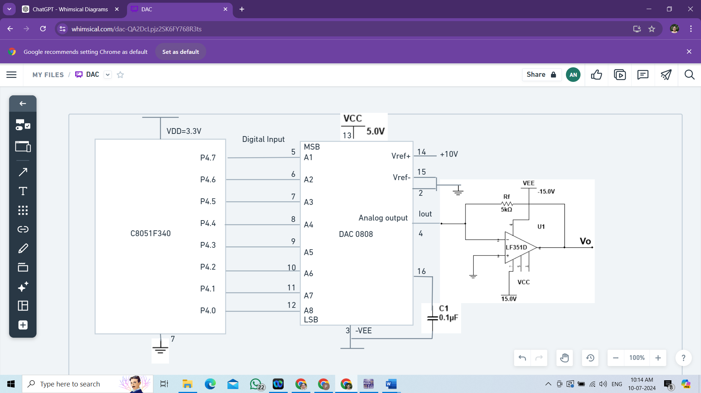
Figure 5.1 Interfacing Diagram of 8-bit DAC with C8051F340
Hardware Connections:
Connect dual power supply of 15V to DAC board. Digital data is available on P4 so Connect flat cable between PL6 connector of EPBF340 board to DAC data lines on DAC board.

Pin Connection | PL6 Connector of EPBF340 | Pin Connection | DAC board data lines socket
1
2
3
4 | P3.3
5
10 | P4.0 | 3 | D0
11 | P4.1 | 4 | D1
12 | P4.2 | 5 | D2
13 | P4.3 | 6 | D3
14 | P4.4 | 7 | D4
15 | P4.5 | 8 | D5
16 | P4.6 | 9 | D6
17 | P4.7 | 10 | D7
18 | 3.3 V |  | NC
19 | 5.0 V | 1 | 5.0 V
20 | GND | 2 | GND

Program: Attach printout of the tested code.

Result:
Observe square and triangular wave on DSO.

Conclusion:

Study Questions:
- Write a program to generate trapezoidal wave using DAC
- Explain different types of DAC

Additional Links:
https://nptel.ac.in/courses/112103174/module2/lec8/1.html
S. Y. B. Tech (ECE)
Semester: IV Subject: Microcontroller and Applications
Name: Class:
Roll No: Batch:
Experiment No: 06
Name of the Experiment: Programming of on chip ADC

Marks
Teacher’s Signature with date
Performed on:
Submitted on:

Aim: Write C program for programming of on chip ADC of C8051F340.

Apparatus: EPBF340 Board, ASK25 board, Connectors

Theory:
Analog to digital converter is among the most widely used device for data acquisition. It is used to convert the analog signals to digital numbers so that microcontroller can read and process them.
On-chip ADC Features:
- 10-Bit ADC
- Up to 200 ksps
- Built-in analog multiplexer with single-ended and differential mode
- V_{REF} from external pin, internal reference, or VDD

Interfacing Diagram:
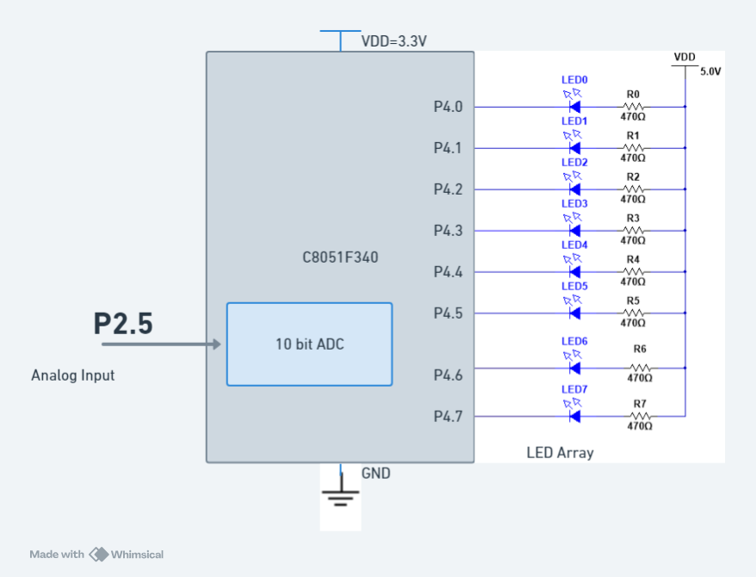
Figure 6.1 Interfacing Diagram for on chip ADC programming

Hardware Connections: Connect single lead wire between P2.5 (Pin15 of PL3 connector) of EPBF340 board and Pin1 of PL10 connector of ASK25. To provide the ground also connect 20pin flat cable between PL6 connector of EBF340 board and PL8 connector of ASK25.
Connect USB cable between PL8 connector of EPBF340 board and PC.
F340 Reference | Device ASK25
P2.5 (Pin15 of PL3 connector) | Pin 1 of PL10 connector (Pot RV2)
P0.4 | TXD
P0.5 | RXD

Program: Attach printout of the tested code.

Result:
Digital output should be observed on the HyperTerminal.

Conclusion:

Study Question:
1. Give the main factor affecting the step size of ADC in C8051F340.
2. Give the formats for control registers associated with C8051F340 ADC.

Additional link:
https://www.silabs.com/documents/public/data-sheets/C8051F34x.pdf

S. Y. B. Tech (ECE)
Semester: IV Subject: Microcontroller and Applications
Name: Class:
Roll No: Batch:
Experiment No: 07
Name of the Experiment: Generation of PWM using C8051F340 to control speed of DC motor

Marks
Teacher’s Signature with date
Performed on:
Submitted on:

Aim: Write C program to generation PWM using C8051F340 to control speed of DC motor

Apparatus: EPBF340 board, DSO, DSO probes, DC motor

Theory:

DC Motors: A direct current (DC) motor is widely used device that translate electrical pulses into mechanical movement. In the DC motor we have only + and _ leads. Connecting them to a DC voltage source moves the motor in one direction. By reversing the polarity, the DC motor will move in the opposite direction.
Unidirectional control:
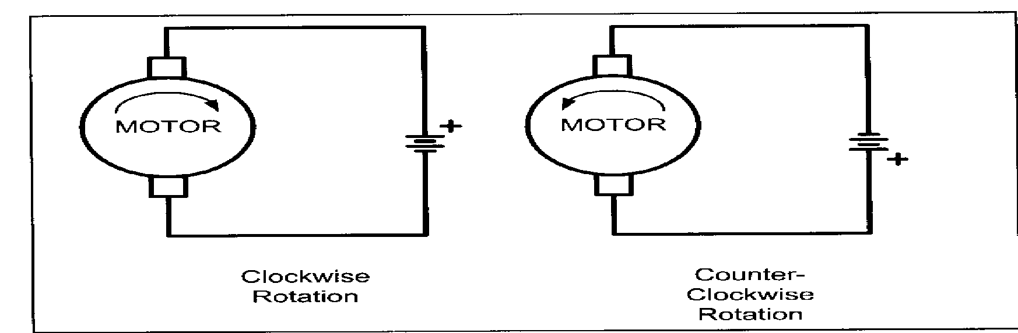
Figure 7.1: Unidirectional control of DC motor

Pulse Width Modulation (PWM):
The speed of motor depends on the three factors: i) load, ii) voltage, and iii) current. For a given fixed load we can maintain the steady speed by using a method called pulse width modulation (PWM). By changing (modulating) the width of the pulse applied to DC motor we can increase or decrease the amount of power provided to the motor , thereby increasing or decreasing the motor speed. Notice that although the voltage has a fixed amplitude, it has a variable duty cycle.
PWM generation in C8051F340:
The Programmable Counter Array (PCA0) provides enhanced timer functionality. The PCA consists of a dedicated 16-bit counter/timer and five 16-bit capture/compare modules. Each module can be used independently to generate a pulse width modulated (PWM) output on its associated CEXn pin. The frequency of the output is dependent on the timebase for the PCA counter/timer. The duty cycle of the PWM output signal is varied using the module's PCA0CPLn capture/compare register.
Interfacing Diagram:
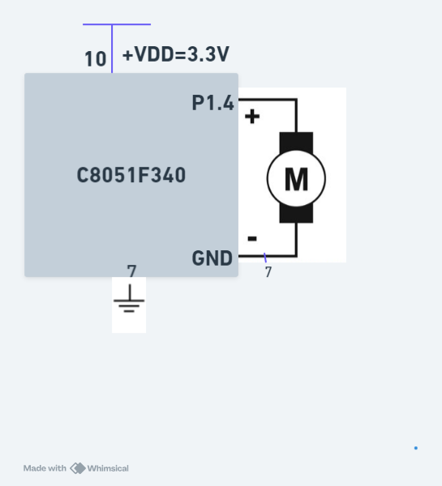
Figure 7.2 Interfacing Diagram of DC motor with C8051F340

Calculations of duty cycle: DutyCycle = (256-PCA0CPHn)/256
Hardware Connections: Output is available on Port pin P1.4. Observe waveform at pin no. 5 of PL3 connector of EPBF340 board with respect to ground on DSO/CRO. After this, connect DC motor between the same pin.

Program: Attach printout of the tested code.

Result:
The duty cycle of the PWM waveform should be observed on DSO/CRO.
OR
DC Motor should run with speed varying w.r.t the change in value of PWM.

Conclusion:

Study Question:
- Define duty cycle.
- Write the steps to program PCA to generate PWM
- Write down the equations for the frequency and duty cycle of PWM in C8051F340
Additional links:
- https://www.silabs.com/documents/public/data-sheets/C8051F34x.pdf
- https://www.microcontroller-project.com/dc-motor-speed-control-using-8051-microcontroller.html

S. Y. B. Tech (ECE)
Semester: IV Subject: Microcontroller and Applications
Name: Class:
Roll No: Batch:
Experiment No: 08
Name of the Experiment: Implement UART with C8051F340

Marks
Teacher’s Signature with date
Performed on:
Submitted on:

Aim: Write a C program for serial communication using C8051F340 to transfer data from C8051F340 to PC
Apparatus: EPBF340 Board, Connectors

Theory: Serial Communication is of two types Synchronous and Asynchronous. The asynchronous mode is used to connect the C8051F340 to PC serial port for the purpose of full duplex serial data transfer.C8051F340 has inbuilt UART (Universal Asynchronous Receiver Transmitter). Baud rate is a significant factor for serial communication of microcontroller with other devices. For communication with PC the baud rate of 9600 is selected.
baud rate generation:
Timer-1 is used to generate baud rate for mode-1 serial communication by using overflow flag of the timer to determine the baud frequency. Timer-1 is used in timer mode-2 as an auto-reload 8-bit timer. The data rate is generated by timer-1 using the following formula.

TH1 = (SYSCLK/Desired baud rate/2/4)

Interfacing Diagram:
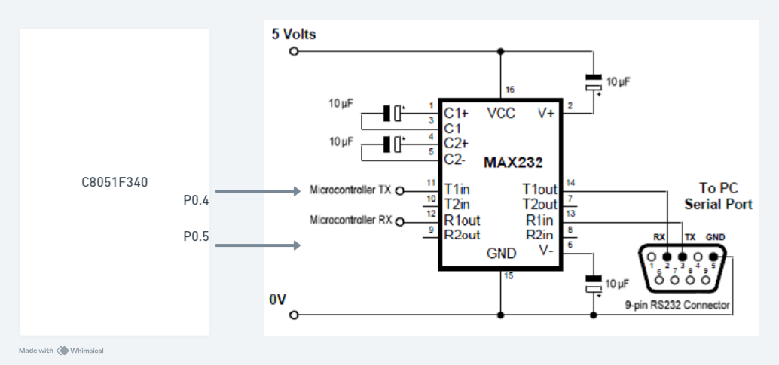
Figure 8.1 Interfacing Diagram for UART

Calculations for Baud Rate:
Hardware Connections: Connect USB cable between PL8 connector of EPBF340 board and PC.

F340 Reference | Device
P0.4 | TXD
P0.5 | RXD

Program: Attach printout of the tested code.

Expected Result:
The string should be displayed on HyperTerminal.

Conclusion:

Study Question:
- Explain the need of MAX232 in serial communication.
- Write the Port Properties for setting Hyper Terminal connection.
- Explain UART registers.

Additional link:
https://exploreembedded.com/wiki/A4.8051_Communication_Protocols:UART,_RS232

S. Y. B. Tech (ECE)
Semester: IV Subject: Microcontroller and Applications
Name: Class:
Roll No: Batch:
Experiment No: 09
Name of the Experiment: Interfacing of Stepper motor with C8051F340.

Marks
Teacher’s Signature with date
Performed on:
Submitted on:

Aim: Write C program for interfacing of Stepper motor with C8051F340 to rotate in clockwise and anticlockwise direction.

Apparatus: EPBF340 board, Stepper motor Board

Theory:
A stepper motor is known by its important property to convert a train of pulses into a precisely defined increment in the shaft position. A stepper motor is a widely used a device that translates electrical pulses into mechanical movement. In applications such as disk drivers, dot matrix printers, and robotics, the stepper motor is used for position control. Every stepper motor has a permanent magnet rotor ( also called as shaft ) surrounded by a stator the most common stator motors have four stator windings that are paired with a centre-tapped common as shown in the figure. This type of stator motor is commonly referred to as four phase stepper motor. The centre tap allows a change of current direction in each of two coils, when a winding is grounded, thereby resulting in polarity change of the stator. Notice that while a conventional motor shaft runs freely, the stepper motor shaft moves in a fixed repeatable increment which allows one to move it to a precise position.
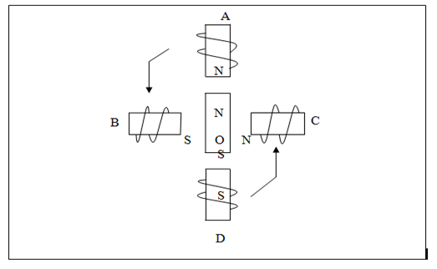
Figure 8.1 Stepper motor windings
This repeatable fixed movement is possible as a result of basic magnetic theory where poles of same polarity repel and opposite attract. The direction of rotation is indicated by the stator poles. The stator poles are determined by the current sent through the wire coils A, B,C and D as shown in Figure 8.1. As the direction of current is changed, the polarity is also changed causing the reverse motion of the rotor. The stepper motor discussed here has a total of six leads: four leads representing the four stator windings and two commons for the centre tapped leads. As the sequence of power is applied to each stator winding, the rotor will rotate. There are several widely used sequences where each has a different degree of precision. The stepping sequence of excitations is as shown in Table 8.1.
Table 8.1 The stepping sequence
Windings | D |  | C |  | B |  | A
Sequence in hex on Port 4 | P4.7 | P4.6 | P4.5 | P4.4 | P4.3 | P4.2 | P4.1 | P4.0
0A | 0 | 0 | 0 | 0 | 1 | 0 | 1 | 0
88 | 1 | 0 | 0 | 0 | 1 | 0 | 0 | 0
A0 | 1 | 0 | 1 | 0 | 0 | 0 | 0 | 0
22 | 0 | 0 | 1 | 0 | 0 | 0 | 1 | 0

Types of Stepper Motor:
There are three main types of stepper motors, they are:
- Permanent magnet stepper
- Hybrid synchronous stepper
- Variable reluctance stepper
Permanent Magnet Stepper Motor: Permanent magnet motors use a permanent magnet (PM) in the rotor and operate on the attraction or repulsion between the rotor PM and the stator electromagnets.
Variable Reluctance Stepper Motor: Variable reluctance (VR) motors have a plain iron rotor and operate based on the principle that minimum reluctance occurs with minimum gap, hence the rotor points are attracted toward the stator magnet poles.
Hybrid Synchronous Stepper Motor: Hybrid stepper motors are named because they use a combination of permanent magnet (PM) and variable reluctance (VR) techniques to achieve maximum power in a small package size.
Advantages of Stepper Motor:
- The rotation angle of the motor is proportional to the input pulse.
- The motor has full torque at standstill.
- Precise positioning and repeatability of movement since good stepper motors have an accuracy of 3 – 5% of a step and this error is non-cumulative from one step to the next.
- Excellent response to starting, stopping and reversing.
- Very reliable since there are no contact brushes in the motor. Therefore the life of the motor is simply dependant on the life of the bearing.
- The motors response to digital input pulses provides open-loop control, making the motor simpler and less costly to control.
- It is possible to achieve very low speed synchronous rotation with a load that is directly coupled to the shaft.
- A wide range of rotational speeds can be realized as the speed is proportional to the frequency of the input pulses.
Applications:
- Industrial Machines – Stepper motors are used in automotive gauges and machine tooling automated production equipment.
- Security – new surveillance products for the security industry.
- Medical – Stepper motors are used inside medical scanners, samplers, and also found inside digital dental photography, fluid pumps, respirators and blood analysis machinery.
- Consumer Electronics – Stepper motors in cameras for automatic digital camera focus and zoom functions.
Interfacing Diagram:
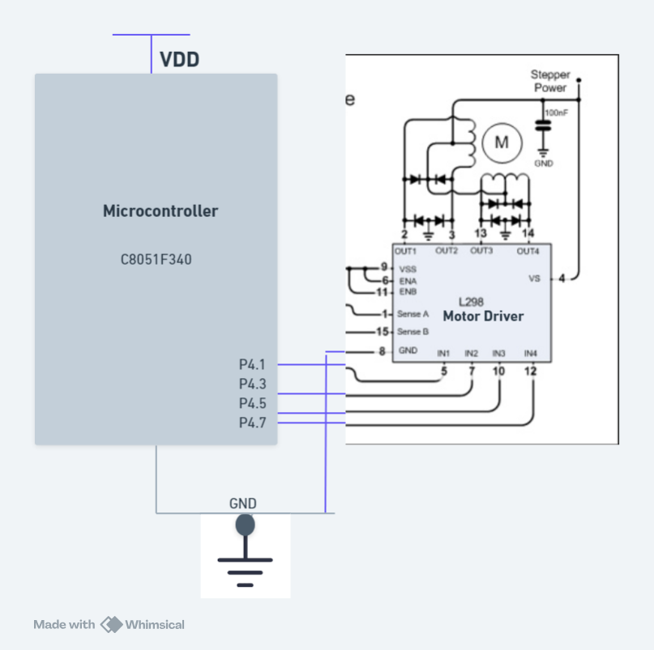
Figure 8.2 Interfacing Diagram of stepper motor with C8051F340
Hardware Connections:
Connect flat cable between PL3 connector of ASK25 and PL6 connector of EPBF340 board. Connect stepper motor at PL4 connector of ASK25. Connect 9V power supply at PL9 connector of ASK25 before connecting the stepper motor. Press DIP switch SW9 on ASK25 to run the motor.
Pin Connection | PL3 Connector of ASK25 | PL6 Connector of EPBF340
11 | Input 1 (A) | P4.1
13 | Input 2 (B) | P4.3
15 | Input 3 (C) | P4.5
17 | Input 4 (D) | P4.7
19 | 5V | 5.0 V
20 | GROUND | GND
Program: Attach printout of the tested code.

Expected Result:
Stepper Motor will rotate in the clockwise and anticlockwise direction

Conclusion:

Study Questions:
- Explain different types of stepper motors and its applications.
- Explain full stepping & half stepping concept of stepper motor.
- List specifications of stepper motor and explain need of driver.
Additional Links:
https://nptel.ac.in/courses/112103174/16

S. Y. B. Tech (ECE)
Semester: IV Subject: Microcontroller and Applications
Name: Class:
Roll No: Batch:
Experiment No: 10
Name of the Experiment: Interfacing EEPROM using SPI with C8051F340

Performed on:

Marks
Teacher’s Signature with date
Submitted on:

Aim: Write a program to write and read data on SPI based EEPROM.

Apparatus: EPBF340 board, ASK25 board, Connectors

Theory:
The Enhanced Serial Peripheral Interface (SPI0) of C8051F340 provides access to a flexible, full-duplex synchronous serial bus. SPI0 can operate as a master or slave device in both 3-wire or 4-wire modes, and supports multiple masters and slaves on a single SPI bus.
SPI0 four wire Master Mode Operation is used to read and write data on EEPROM. The four signals used by SPI0 are MOSI, MISO, SCK, NSS.
SPI0CFG, SPI0DAT, and SPI0CN SFRs of SPI are configured to select 4 wire master mode.
SPI clock frequency is configured using following formula.

SPI0CKR = (SYSCLK/(2*SPI_CLOCK))-1

25AA160 16 Kbit Serial Electrically Erasable PROMs is used. The memory is accessed via a simple Serial Peripheral Interface compatible serial bus. The bus signals required are a clock input (SCK) plus separate data in (SI) and data out (SO) lines. Access to the device is controlled through a Chip Select (CS) input.
Data written data on EEPROM and read from EEPROM is displayed on LCD.

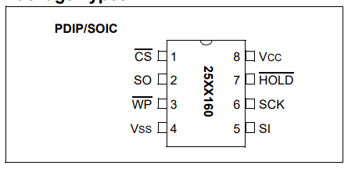
Figure 9.1 EEPROM 25AA160
Interfacing Diagram:
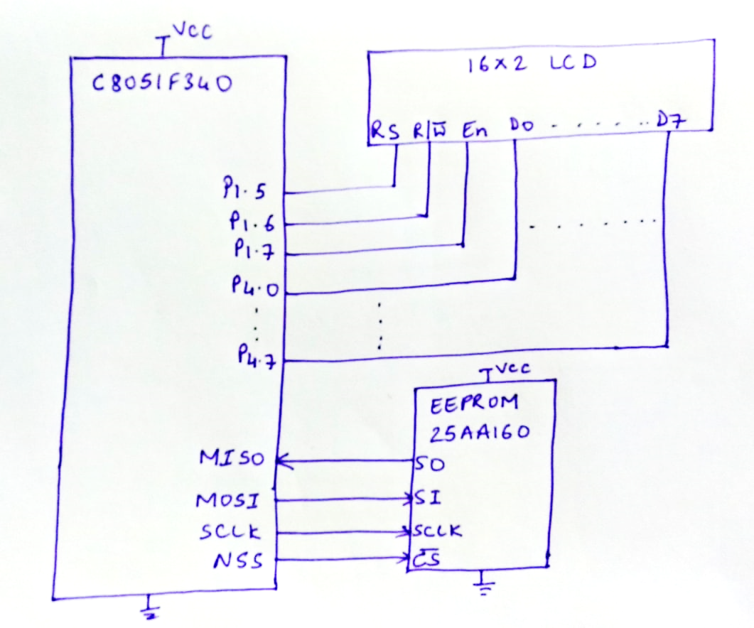

Figure 9.2 Interfacing Diagram EEPROM using SPI

Hardware Connections: Connect FRC cable between PL7 connector (SPI) of EPBF340 board and PL1 of ASK 25.
Connect flat cable between PL3 connector of ASK25 and PL3 connector of EPBF340 board.

Program: Attach printout of the tested code.

Expected Result:
EEPROM data should be displayed on LCD.

Conclusion:

Study Questions:
- Explain SFR of SPI0 in detail.
- Compare SPI with I2C

Additional Links:
https://www.analog.com/en/analog-dialogue/articles/introduction-to-spi-interface.html
https://microcontrollerslab.com/introduction-to-spi-communication-protocol/
http://ww1.microchip.com/downloads/en/devicedoc/21231d.pdf

